GEC1044 Chinese Medicine: Theory and Practice
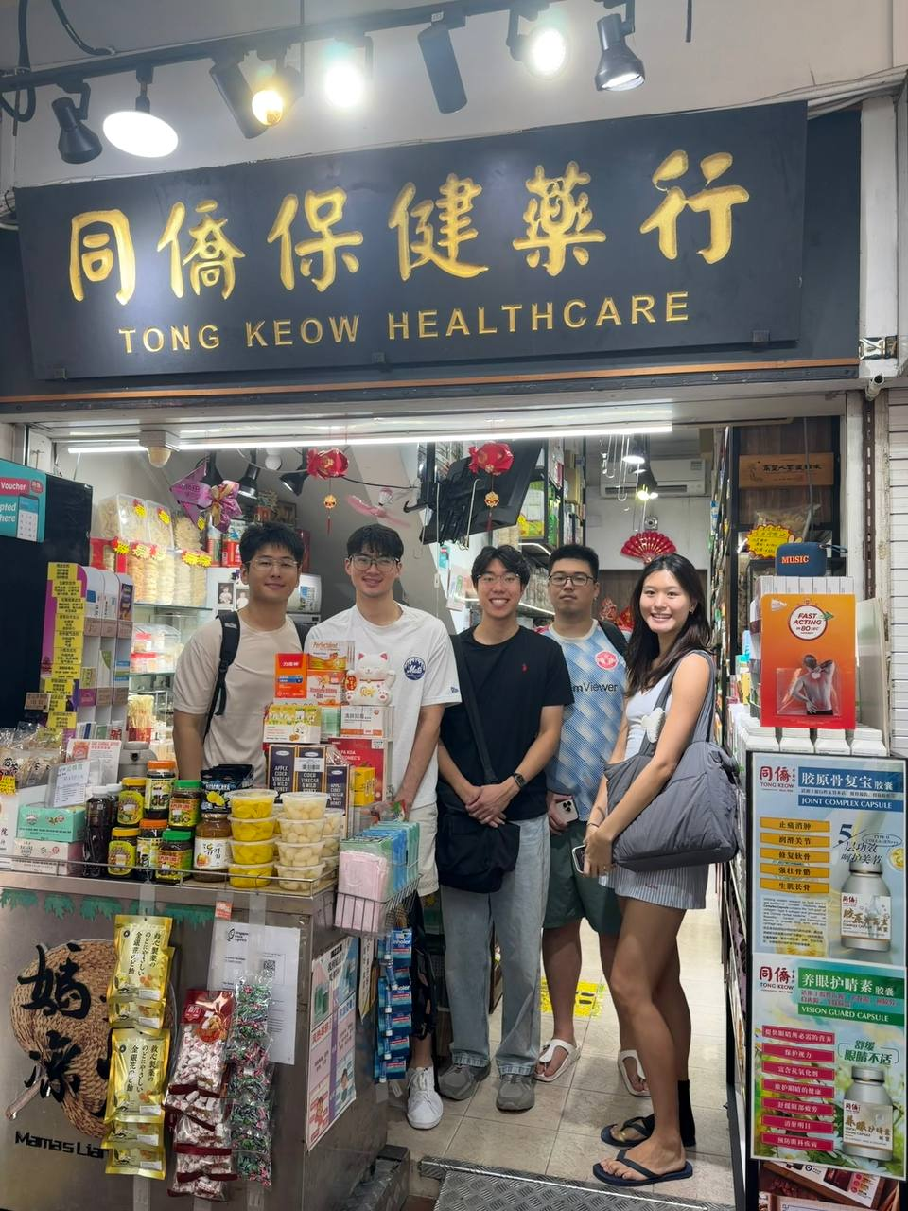

GEC1044 Field Trip Report
Traditional Chinese Medicine at Tong Keow Healthcare
Tutorial group: TD3, Group 2
TA: Lin Shi Ting
Field site: Tong Keow Healthcare
Blk 809 Hougang Central, #01-170, Singapore 530809
Date of field visit: 13 September 2026
Word count: 1927

Name | Student ID
Lou Yu | A0244992R
Chang Tze Yi Othniel | A0273716Y
Li Xudong | A0324706H
Curtis Chang Kai Xian | A0281680B
Hu Zhixuan, Shirley | A0258532B

1 Introduction
At Tong Keow’s Hougang outlet, herbs and soup packs sit beside everyday foods. Staff described purchases for nourishment, throat comfort and needs linked to daily routines. These displays show how Traditional Chinese Medicine (TCM) enters ordinary shopping and cooking.
We argue that the medicine hall keeps traditional ingredients usable in household life by linking them with food, convenient preparations and local retail practices. Our question is how these practices sustain TCM while changing how people encounter it. We examine this through displays, staff interviews and published sources, without assessing clinical effectiveness or sales performance.

2 Fieldwork and the neighbourhood medicine hall

2.1 How we conducted the fieldwork
We visited Tong Keow on 13 September 2026, photographed displays and interviewed one staff member. The transcripts, presentation script and photographs form the basis of this report. When a transcript is unclear, we use only meanings supported by the other records.
We separate field observations, staff comments, published references and our interpretations. Demand descriptions reflect one employee’s experience and may favour products the shop sells. They are not independent evidence of customer preferences.

2.2 Tong Keow and its mixed retail model
Tong Keow’s profile states that the medicine hall was founded in Toa Payoh in 1968 and is now run by second-generation family owners. Its promotional materials feature American ginseng, monk fruit, cooling teas, pills and plasters (Tong Keow Medical Hall 2022; “Instagram Reel about Tong Keow Medical Hall” n.d.).

The company advertises physician consultations, acupuncture and cupping for indigestion, colds and sprains (“Instagram Reel about Tong Keow Medical Hall” n.d.). We did not verify these services or observe consultations. Our visit focused on the retail space. Branded soup packs beside herbs, grains and foods connect the branch to the wider business. This mixed range lets shoppers encounter herbal products while buying groceries.
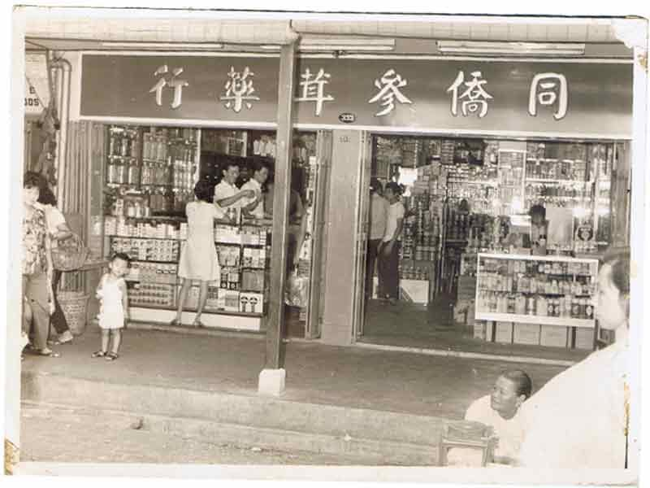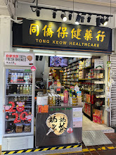
Figure 1 Tong Keow storefronts Past and present

2.3 Hougang and the customers described by staff
Staff described mainly Chinese, middle-aged and older customers, including people in their forties and fifties. Hougang Central had about 4,620 residents in June 2025. Around 1,070 were aged 65 or above (23%) (Singapore Department of Statistics 2025). These figures give neighbourhood context, but do not identify actual shoppers.
Hougang also has a rich Teochew history. The National Heritage Board describes the community around Tou Mu Kung and its fishing, farming and rubber-growing activities (National Heritage Board n.d.). This provides cultural context, but heritage alone cannot explain current buying habits or establish customers’ dialect identities.
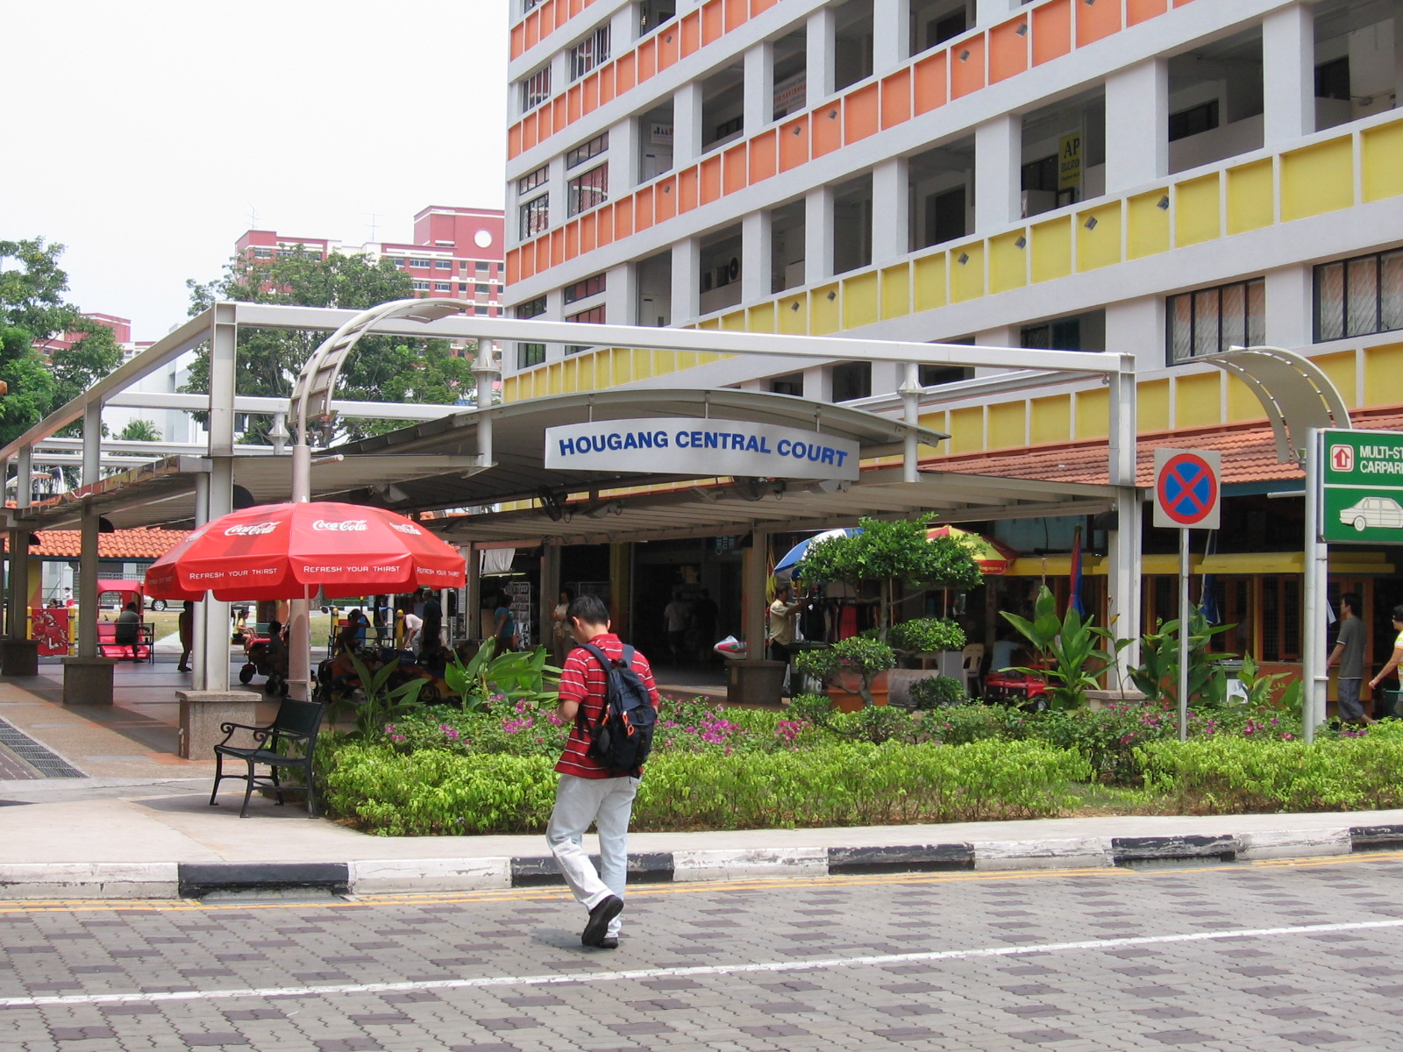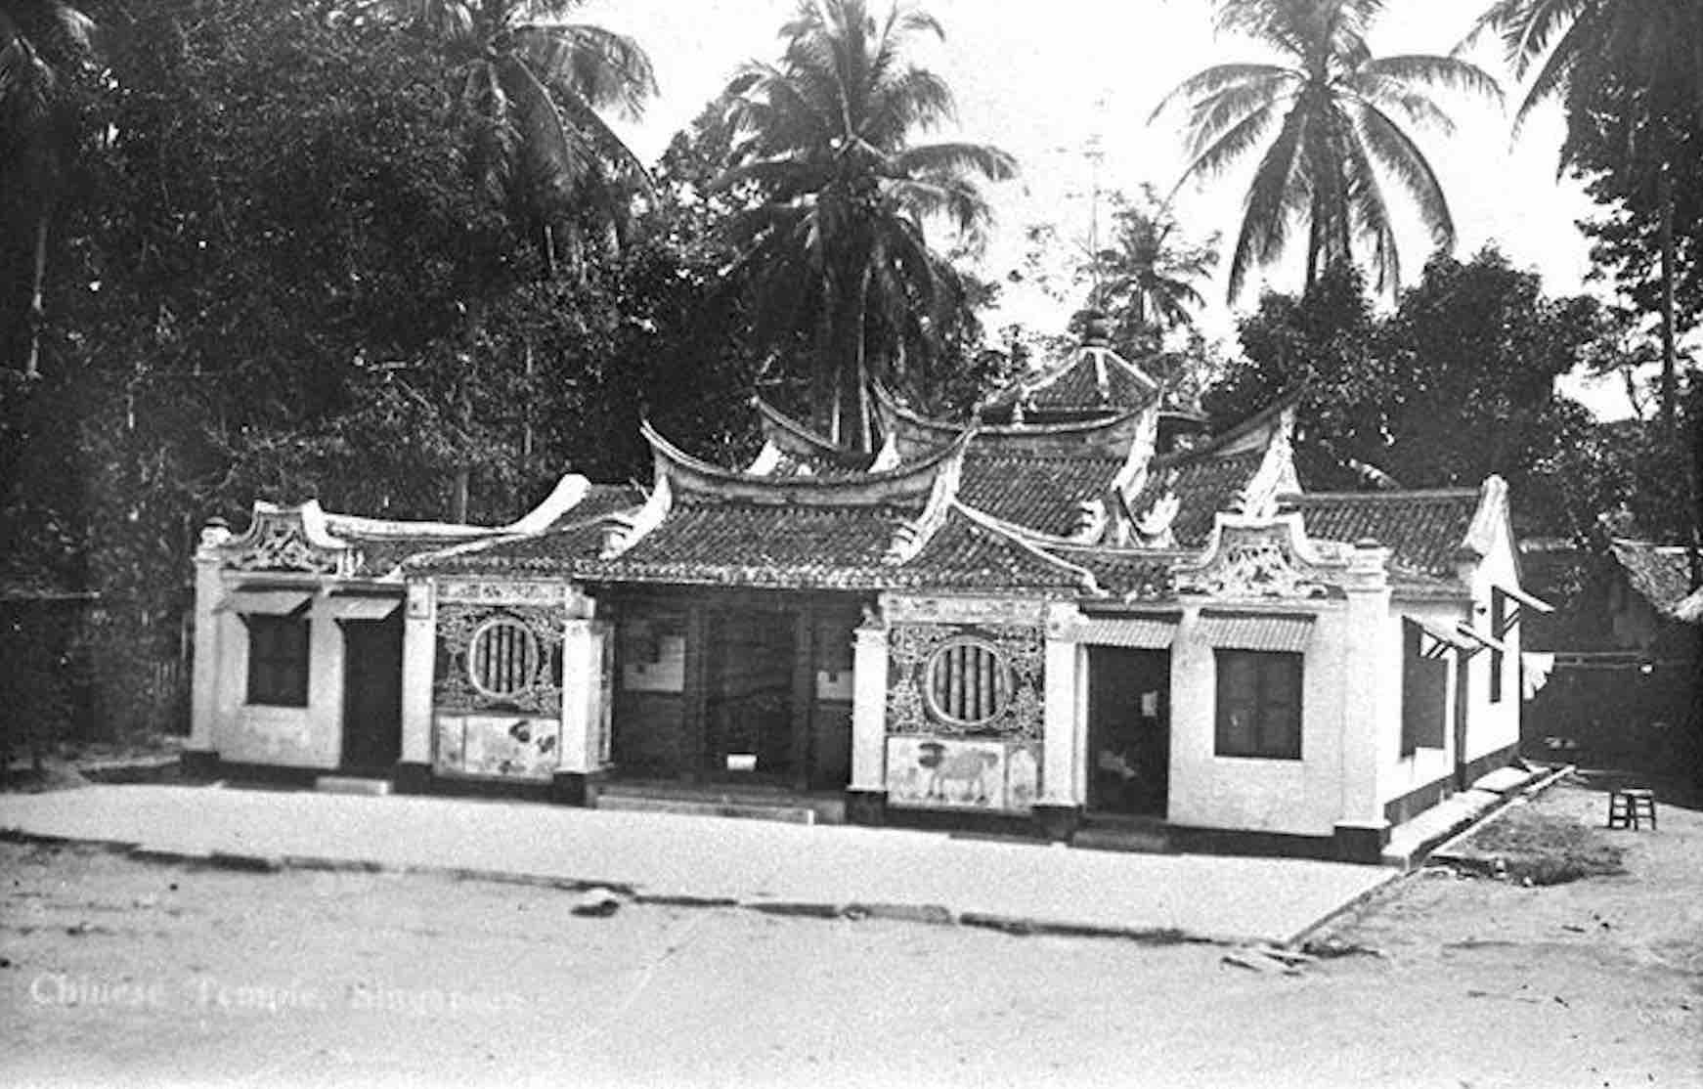
Figure 2 Hougang setting and historical context

3 Food and everyday care

3.1 Household nourishment
Staff named Dang Shen (党参), Huang Qi (黄芪), Yu Zhu (玉竹), Huai Shan (淮山), red dates (红枣) and goji (枸杞) as common soup ingredients. They also described ginseng (人参), American ginseng (西洋参) and monk fruit (罗汉果) as common purchases. Table A1 records nine profiles.
Soup gives herbs a familiar household purpose. The lecture describes Chinese medicine as a cultural framework shaping food and health habits. Nourishing life (养生) and medicine and food sharing a source (药食同源) help explain this connection. Lim et al. (2005) identify health maintenance as an important reason for dietary herb use. Cooking offers one route for this practice: households use traditional ingredients in meals, not only when seeking treatment. A familiar meal gives nourishment a practical place in daily life, so using herbs need not begin with a specific illness.

3.2 Soups and light nourishment
Table A2 retains five presentation labels: Qing Bu Liang (清补凉), Dang Shen–Huang Qi (党参北芪补气汤), Yu Zhu–Huai Shan (玉竹淮山润燥汤), goji–red date (枸杞红枣养生汤) and Five Finger Fig (五指毛桃健脾汤). Staff described uses such as aiding digestion (助消化), moistening (润燥) and light nourishment (qing bu / 清补). Light nourishment offers an everyday dietary approach alongside stronger tonification (da bu / 大补). Pre-selected packs make these ideas easier to use because households receive portioned ingredients and complete the cooking.
Several labels, especially Five Finger Fig, emphasise Spleen or digestive support. The TCM Spleen is a broader functional system, not simply the anatomical organ (World Health Organization 2022). Other labels describe moistening and general nourishment. The shared cooking format therefore carries different traditional purposes, rather than one uniform treatment.

3.3 Climate and soup preferences
Staff linked demand for monk fruit and lighter soups to Singapore’s hot and humid environment. Singapore lacks the four temperate seasons used in classical seasonal guidance. Their explanation suggests that seasonal health advice is adapted to local conditions. However, climate alone cannot establish an individual’s TCM pattern or the suitability of a cooling product.
The Suwen (素问) links health maintenance to harmony with seasonal cycles (Unschuld and Tessenow 2011, 45–57). Yu Zhu’s traditional moistening profile connects it with autumn dryness (qiu zao / 秋燥). It nourishes Yin and generates fluids for the Lung and Stomach (Hong Kong Polytechnic University n.d.; see table A1). In Singapore, Yu Zhu appears in the recorded Yu Zhu–Huai Shan soup. Staff described gentle moistening and fluid replenishment. This example shows how traditional ideas can be explained in a different climate.
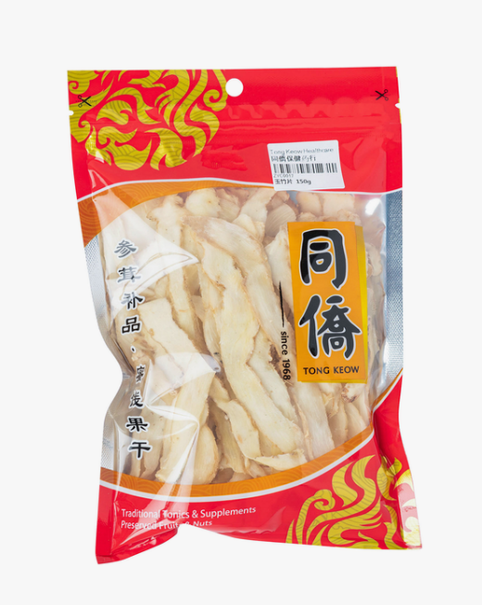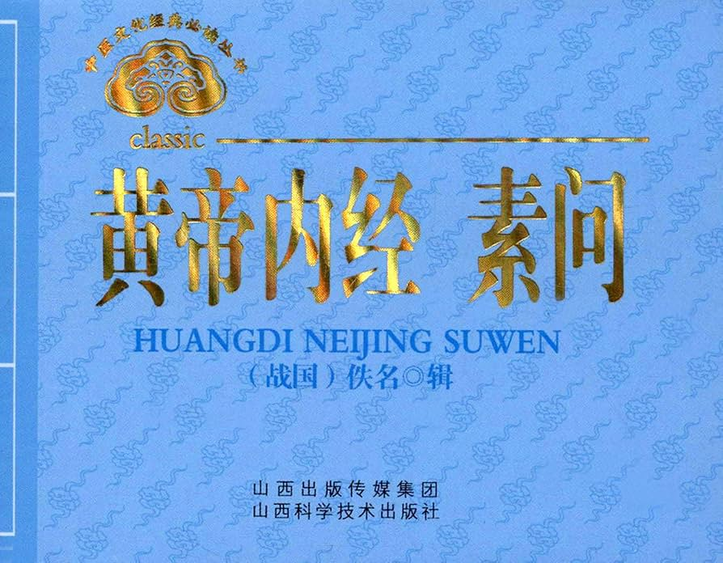
Figure 3 Packaged Yu Zhu (玉竹) and the Huangdi Neijing Suwen (黄帝内经素问）

4 Convenience and changing lifestyles

4.1 Younger buyers and preparation
Staff said younger customers preferred teas, supplements and simple preparations to raw herbs. Table A3 records eight product categories, including ginseng tonics, herbal teas, soup packs, mood-support products and medicated oils. This account points to product form as one reason traditional ingredients may fit younger buyers’ routines.
Pre-selected soup packs shift selection and portioning away from buyers, while households still cook. Capsules reduce preparation further. Staff explained ingredient uses, and a photographed multi-buy promotion presented packs through a familiar supermarket offer. Buyers can start with a prepared combination instead of choosing herbs and quantities. Convenience changes the work needed to bring traditional ingredients into household routines.

4.2 Lifestyle pressures and packaged products
Staff linked late nights, long work hours and prolonged phone use to demand for liver-care or mood-support products. Nature’s Green Mind Soothe Capsules use the language of soothing Liver-related constraint (疏肝解郁) and are listed by HSA as a Singapore-manufactured Chinese Proprietary Medicine (CPM) (Health Sciences Authority 2025b). Such descriptions connect TCM terminology with familiar concerns about stress and mental well-being. These are retail associations, rather than clinical diagnoses or evidence that the products treat mental illness.
Kumari’s (2024) report on ADP’s 2023 survey found weekly work-related stress among 68% of Singapore workers, compared with 61% across surveyed Asia-Pacific markets. This gives broader context to the shop’s product language, although it does not measure Tong Keow customers’ reasons for purchase. Together with Section 4.1, the staff account suggests that lifestyle pressures and convenience help explain demand for packaged products: familiar concerns are expressed through traditional terms, while capsules offer a preparation format that fits daily routines.

4.3 Preparation and product appeal
Lower-demand examples help explain the appeal of simpler products. Staff named Ban Zhi Lian (半枝莲), specialist herbs requiring combinations and strong tonic formulas (大补方) (Table A4). They linked lower appeal to unfamiliarity and preparation effort. Staff also linked stronger tonics’ lower appeal to a local preference for lighter qing bu (清补) in Singapore’s hot and humid climate. They reported stocking fewer slow-selling items. These comments concern retail demand, not medical unsuitability. Unfamiliar combinations may need more advice and preparation. Prepared packs reduce these demands, helping explain staff-reported differences in appeal.

5 Localisation and cultural change

5.1 Imports and local production
Staff explained that most imports come from China because of the wider variety and lower cost, while local cultivation remains limited. Table A5 presents five examples of Singapore-linked products and organises them by cultivation, manufacture, processing or packing, and branding. Local manufacture and local cultivation are separate stages: ingredients may be grown elsewhere while manufacturing takes place in Singapore. Each stage therefore represents a different kind of connection with Singapore. These distinctions show that localisation can occur through production and retail practices even when cultivation remains overseas (Yang 2022).
Product form and intended use also shape regulation. Finished Chinese Proprietary Medicines (CPMs) require HSA product listing and the relevant dealer licence (Health Sciences Authority 2026a, 2026b). Raw medicinal materials and culinary foods fall under separate categories. Permitted materials may be used in soups or drinks for non-medicinal purposes (Singapore Food Agency 2025). Tong Keow displays these products together on its shelves, but each product type retains its own regulatory status.

5.2 Packaging and trust
Packaging makes product information visible. CPM labels must provide English information on ingredients, batch numbers, expiry dates and supply-chain details(Health Sciences Authority 2025a, sec. 5). For CPMs, these requirements support identification and traceability. Buyers can identify the product and its source. HSA listing addresses safety and quality, but does not demonstrate clinical effectiveness (Health Sciences Authority 2026a).
Staff emphasised fresh colour and sulphur-free materials. Field photographs show a sulphur-free claim on Dang Shen and a separate American ginseng label. The first presents a processing claim, while the second identifies the material. Together, they show how labels build shopper confidence by communicating processing information and product identity.
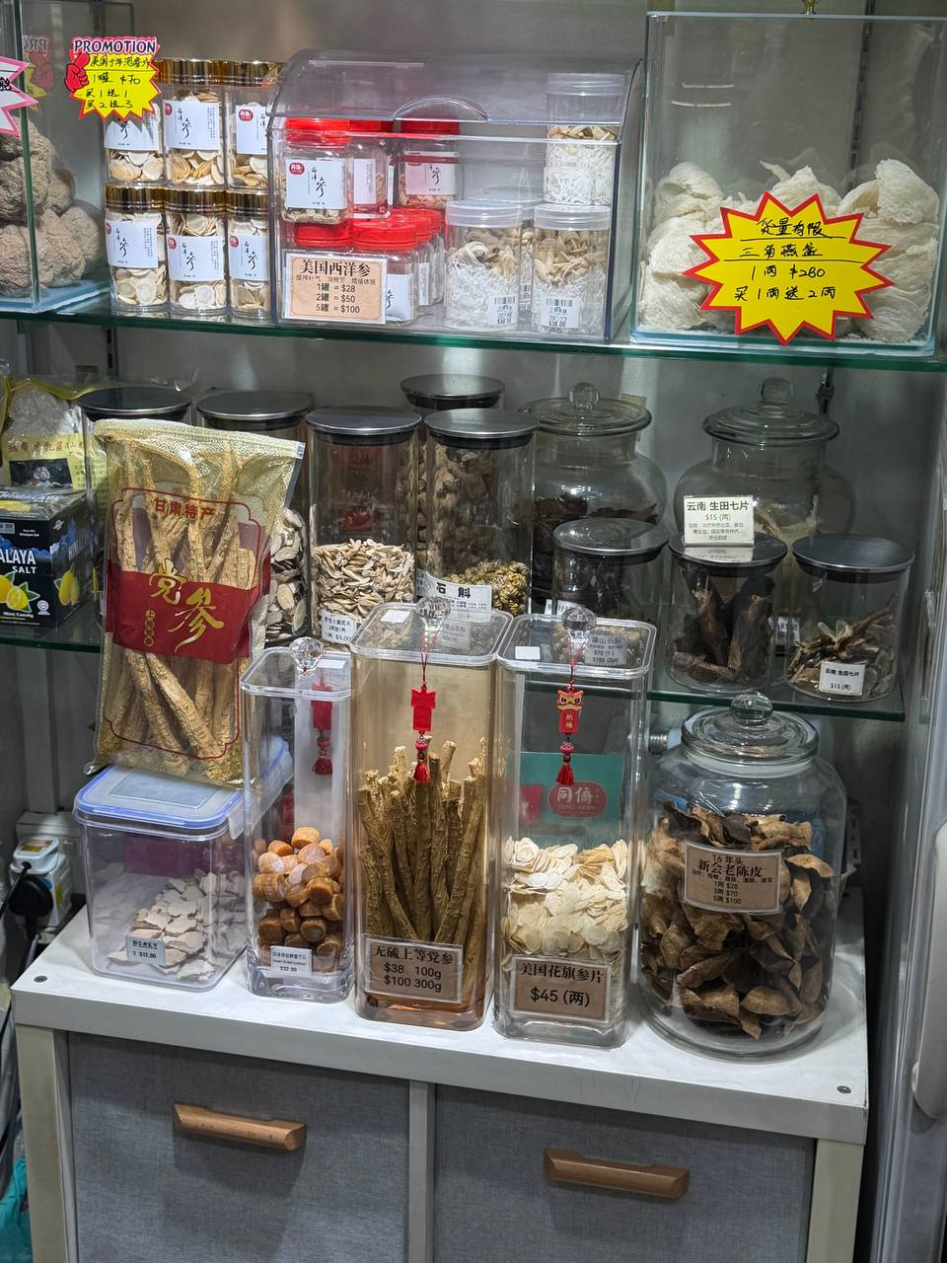
Figure 4 HSA illustration and Tong Keow herb display

5.3 Food and cultural contact
Staff said most customers were Chinese, while some Malay customers bought dessert ingredients and some Indian customers bought nuts. Everyday foods may give different communities familiar reasons to enter the shop. These purchases do not require a shared understanding of TCM. The mixed range therefore suggests several household uses within one retail space.
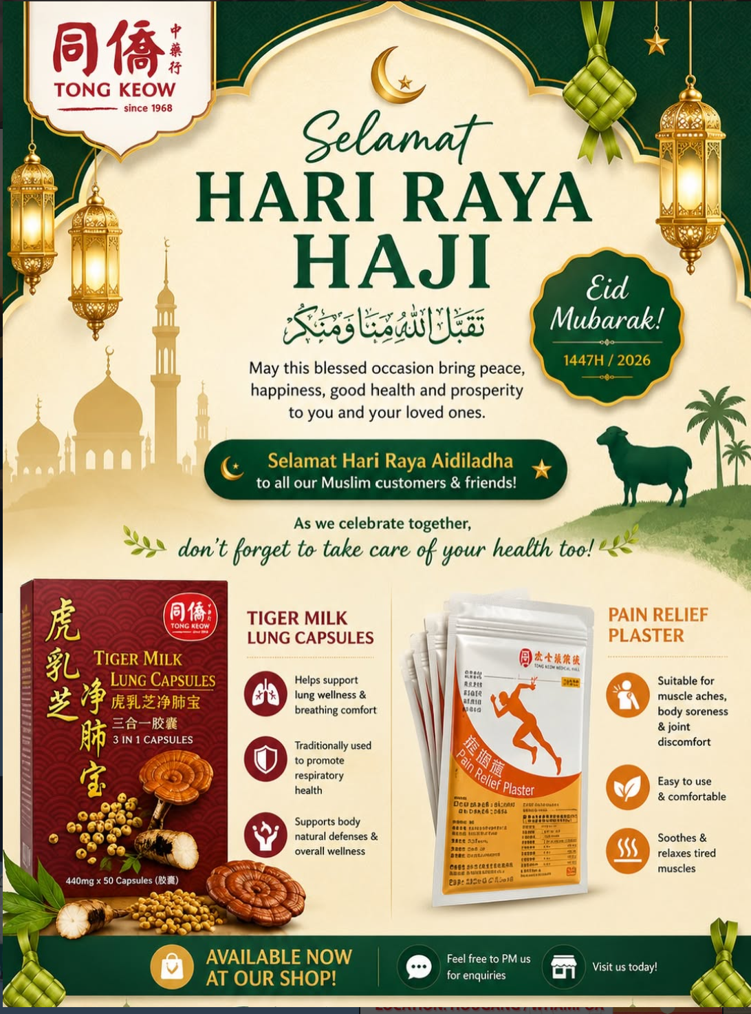
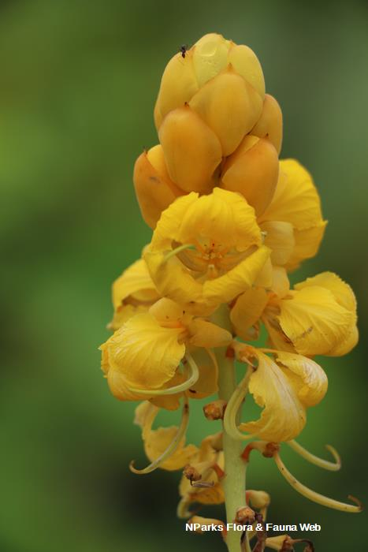
Course material on senna (番泻叶) shows that the same plant can have different meanings in Chinese and Malay medicine. This helps explain how similar materials can serve different cultural routines. But purchases alone cannot establish cultural exchange or reveal shoppers’ beliefs. Customer interviews would show whether buyers regard these products as food, medicine or both.

Figure 5 Tong Keow’s Hari Raya Haji Advertisement (left) and senna flowers (right).

6 Retail adaptation and individual assessment
Tong Keow shows how traditional medicine adapts to everyday life. Food gives herbs a household role, prepared packs reduce effort, and packaging explains uses and origins. Unschuld (2018) describes medicine adapting to social and political settings. Yang (2022) traces Singapore’s modernisation through state, professional and religious influences. These accounts help explain the shop’s use of familiar foods and prepared products.
These products are easier to use, but convenience does not establish individual suitability. A complaint such as fatigue alone cannot guide treatment. Pattern differentiation (辨证论治) requires a fuller assessment of signs and symptoms (World Health Organization 2022). Table A6 therefore records retail associations with complaints and wellness concerns, not physician prescribing data.

7 Limitations
One visit and one interview cannot establish demand trends or explain customers’ own views. Complete recipes, sourcing records and purchasing records were unavailable. Mind Soothe’s Singapore manufacture is confirmed, but its ingredient origins remain unknown. Staff named the category, not the brand. Physician presence was unclear, and we recorded no consultation, prescription or outcome. Practitioner regulation provides background, but does not verify an outlet physician’s role (Ministry of Health 2026).
Customer interviews could test explanations of convenience and trust; sales records and branch comparisons could assess demand. Where records are unclear, we avoid reconstructing recipes or attributing external products to Tong Keow. These gaps limit generalisation, but the case still reveals how one medicine hall presents TCM within Singapore’s everyday retail setting.

8 Conclusion
Tong Keow’s significance lies in making traditional ingredients accessible through ordinary routines. Soup illustrates nourishing life (养生) and medicine and food sharing a common origin (药食同源), while packs and capsules adapt preparation to contemporary lifestyles. Local production links, labels and a mixed food range place these practices within Singapore’s commercial and cultural setting.
These adaptations may sustain engagement with TCM while shifting knowledge and preparation from households towards businesses. Our evidence supports this interpretation of retail practice, but cannot establish effectiveness, customer motivation or wider trends. The medicine hall helps maintain everyday access to TCM; individual treatment still requires the assessment associated with treatment based on pattern differentiation (辨证论治).

References

Health Sciences Authority. (2025a, January). Guidelines on Chinese Proprietary Medicines product listing.
Health Sciences Authority. (2025b). Listing of licensed Chinese Proprietary Medicine products [Data set; updated August 7, 2026]. data.gov.sg. Retrieved October 4, 2026.
Health Sciences Authority. (2026a, April 6). How Chinese Proprietary Medicines are regulated by HSA.
Health Sciences Authority. (2026b, March 13). Overview of importer, wholesaler and manufacturer’s licences.
The Hong Kong Polytechnic University. (n.d.). Fragrant Solomonseal rhizome. Chinese Herbal Medicine Database.
[Instagram reel about Tong Keow Medical Hall]. (n.d.). Instagram.
Kumari, J. (2024, January 24). 68% of Singapore workers experience weekly stress at the workplace: Survey. People Matters Global.
Lim, M. K., Sadarangani, P., Chan, H. L., & Heng, J. Y. (2005). Complementary and alternative medicine use in multiracial Singapore. Complementary Therapies in Medicine, 13(1), 16–24.
Ministry of Health. (2026, February 10). About.
National Heritage Board. (n.d.). Hougang heritage trail. Roots.
Singapore Department of Statistics. (2025). Resident population by planning area/subzone, age group and type of dwelling, June 2025 [Data set].
Singapore Food Agency. (2025, November). List of Chinese medicinal materials (CMM) commonly used in food.
Tong Keow Medical Hall. (2022, August 29). Serving the community with heart since 1968 [Status update]. Facebook.
Unschuld, P. U. (2018). Traditional Chinese medicine: Heritage and adaptation (B. Andrews, Trans.). Columbia University Press.
Unschuld, P. U., & Tessenow, H. (2011). Huang Di nei jing su wen: An annotated translation of Huang Di’s Inner Classic—Basic Questions (Vol. 1). University of California Press.
World Health Organization. (2022). WHO international standard terminologies on traditional Chinese medicine.
Yang, Y. (2022). A brief history of Chinese medicine in Singapore. In V. Lo & M. Stanley-Baker (Eds.), Routledge handbook of Chinese medicine (pp. 524–536). Routledge.

References
Health Sciences Authority. 2025a. Guidelines on Chinese Proprietary Medicines Product Listing. January. https://file.go.gov.sg/hsa-cpm-listing-fsc-guidelines.pdf
Health Sciences Authority. 2025b. “Listing of Licensed Chinese Proprietary Medicine Products.” Data set. Data.gov.sg. Updated August 7, 2026. Accessed October 4, 2026. https://data.gov.sg/datasets/d_2ae2e6beb458d059318c1c14ad899f98/view
Health Sciences Authority. 2026a. “How Chinese Proprietary Medicines Are Regulated by HSA.” April 6. https://www.hsa.gov.sg/announcements/how-chinese-proprietary-medicines-are-regulated-by-hsa/
Health Sciences Authority. 2026b. “Overview of Importer, Wholesaler and Manufacturer’s Licences.” March 13. https://www.hsa.gov.sg/chinese-proprietary-medicines/manufacturing-import-wholesale/dealers-licence/overview/
Hong Kong Polytechnic University. n.d. “Fragrant Solomonseal Rhizome.” Chinese Herbal Medicine Database. Accessed October 15, 2026. https://herbaltcm.sn.polyu.edu.hk/herbal/fragrant-solomonseal-rhizome
[Instagram Reel about Tong Keow Medical Hall]. n.d. Instagram video. Accessed October 15, 2026. https://www.instagram.com/reel/DYn5mkylQw9/
Kumari, Jagriti. 2024. “68% of Singapore Workers Experience Weekly Stress at the Workplace: Survey.” People Matters Global, January 24. https://www.peoplemattersglobal.com/news/culture/68-of-singapore-workers-experience-weekly-stress-at-the-workplace-survey-40095
Lim, M. K., P. Sadarangani, H. L. Chan, and J. Y. Heng. 2005. “Complementary and Alternative Medicine Use in Multiracial Singapore.” Complementary Therapies in Medicine 13 (1): 16–24. https://doi.org/10.1016/j.ctim.2004.11.002
Ministry of Health. 2026. “About.” TCM Practitioners. February 10. https://hpp.moh.gov.sg/tcm-practitioners/about/
National Heritage Board. n.d. “Hougang Heritage Trail.” Roots. Accessed October 15, 2026. https://www.roots.gov.sg/places/places-landing/trails/Hougang-Heritage-Trail
Singapore Department of Statistics. 2025. “Resident Population by Planning Area/Subzone, Age Group and Type of Dwelling, June 2025.” Data set. https://www.singstat.gov.sg/find-data/explore-data-themes/population/geographic-distribution/latest-news-data
Singapore Food Agency. 2025. List of Chinese Medicinal Materials (CMM) Commonly Used in Food. November. https://www.sfa.gov.sg/docs/default-source/tools-and-resources/list-of-chinese-medicinal-materials-cmm3042e12552534dfca3da77d54f1b938b.pdf
Tong Keow Medical Hall. 2022. “Serving the Community with Heart since 1968.” Facebook, August 29. https://www.facebook.com/TKmedical/photos/603606751228617/
Unschuld, Paul U. 2018. Traditional Chinese Medicine: Heritage and Adaptation. Translated by Bridie Andrews. Columbia University Press. https://cup.columbia.edu/book/traditional-chinese-medicine/9780231175012/
Unschuld, Paul U., and Hermann Tessenow. 2011. Huang Di Nei Jing Su Wen: An Annotated Translation of Huang Di’s Inner Classic—Basic Questions. Vol. 1. University of California Press. https://www.ucpress.edu/books/huang-di-nei-jing-su-wen/hardcover
World Health Organization. 2022. WHO International Standard Terminologies on Traditional Chinese Medicine. World Health Organization. https://www.who.int/publications/i/item/9789240042322
Yang, Y. 2022. “A Brief History of Chinese Medicine in Singapore.” In Routledge Handbook of Chinese Medicine, edited by Vivienne Lo and Michael Stanley-Baker, 524–36. Routledge. https://doi.org/10.4324/9780203740262-42

Appendix A Supporting fieldwork and reference data
Table A1 Staff-described commonly purchased herbs

Herb | Nature & Flavour | Meridian | Function | Application
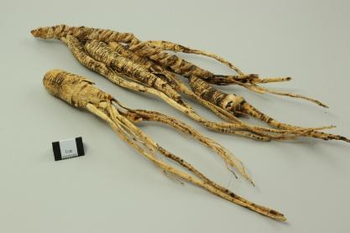  人参 Ren Shen  Ginseng (root) | Sweet, slightly bitter; neutral | Heart, Spleen, Lung | Ginseng strongly tonifies original Qi and supports the Spleen and Lung. It generates fluids and calms the spirit. | Poor appetite, fatigue and breathlessness in Qi-deficiency patterns; thirst from fluid depletion.
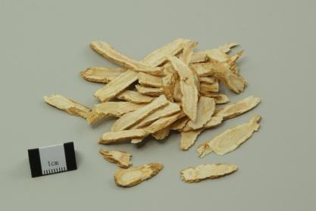  西洋参 Xi Yang Shen  American ginseng (root) | Sweet, slightly bitter; cool | Heart, Lung, Kidney | American ginseng tonifies Qi and nourishes Yin. It clears heat and generates fluids. | Fatigue, dry mouth, thirst and cough in Qi–Yin deficiency with deficiency heat.
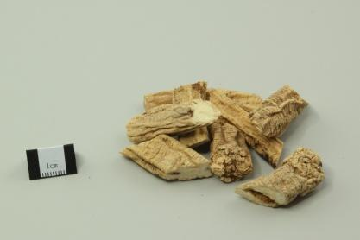  党参 Dang Shen  Codonopsis (root) | Sweet; neutral | Spleen, Lung | Dang Shen tonifies middle Qi and strengthens Spleen and Lung functions. | Poor appetite, loose stools, fatigue and shortness of breath in Spleen–Lung Qi deficiency.
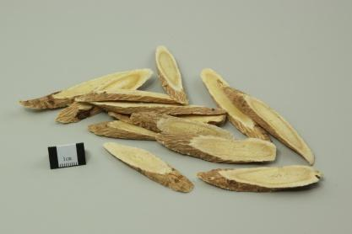  黄芪 Huang Qi  Astragalus/milkvetch (root) | Sweet; warm | Spleen, Lung | Huang Qi tonifies Qi and strengthens exterior defence. It promotes fluid discharge and tissue repair. | Fatigue, poor appetite and loose stools in Qi deficiency; spontaneous sweating from weak exterior defence.
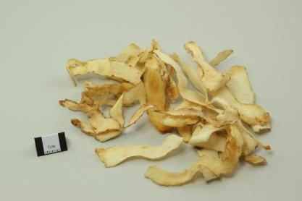  玉竹 Yu Zhu  Fragrant Solomon’s seal (rhizome) | Sweet; slightly cold | Lung, Stomach | Yu Zhu nourishes Yin and moistens dryness. It generates fluids and relieves thirst. | Dry cough, dry throat and thirst in Lung–Stomach Yin deficiency.
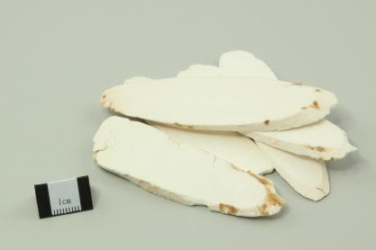  淮山／山药 Huai Shan / Shan Yao  Chinese yam (rhizome) | Sweet; neutral | Spleen, Lung, Kidney | Huai Shan supports the Spleen and Stomach. It generates fluids, benefits the Lung and strengthens the Kidney. | Poor appetite and persistent diarrhoea in Spleen deficiency; chronic cough in Lung deficiency; frequent urination in Kidney deficiency.
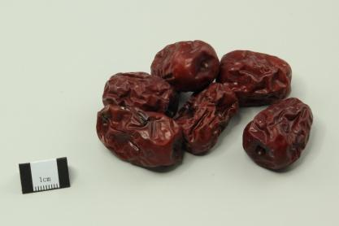  红枣／大枣 Hong Zao / Da Zao  Red dates/jujube (fruit) | Sweet; warm | Spleen, Stomach | Red dates tonify middle Qi, nourish Blood and calm the spirit. | Poor appetite, tiredness and loose stools in Spleen-deficiency patterns.
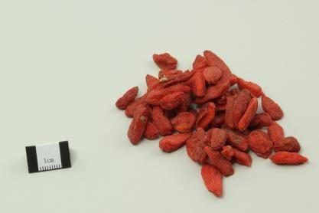  枸杞子 Gou Qi Zi  Goji/wolfberry (fruit) | Sweet; neutral | Liver, Kidney | Goji nourishes the Liver and Kidney. It replenishes essence and supports vision. | Dizziness, aching lower back and knees, and impaired vision in Liver–Kidney deficiency patterns.
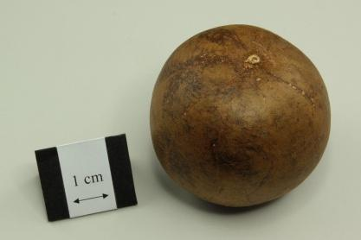  罗汉果 Luo Han Guo  Monk fruit (fruit) | Sweet; cool | Lung, Large Intestine | Monk fruit clears heat, moistens the Lung and lubricates the intestines. | Dry cough, sore throat and hoarseness in Lung-heat dryness; constipation from intestinal dryness.

Table A2 Five recorded soup labels and stated uses

Soup label | Ingredients available from the record | Purpose and main use
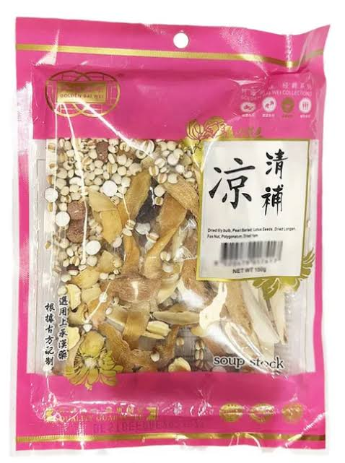  Qing Bu Liang 清补凉 | Chinese yam, Solomon’s seal, lotus seeds, fox nuts, Job’s tears and lily bulbs appear in the illustrated record. We could not verify the full recipe or quantities. | Light nourishment and everyday care in the presentation.
Dang Shen and Huang Qi soup  党参北芪补气汤 | The record names Dang Shen and Huang Qi. The complete recipe is unknown. | Qi support and nourishment in the presentation.
Yu Zhu and Huai Shan soup  玉竹淮山润燥汤 | The record names Yu Zhu and Huai Shan. The complete recipe is unknown. | Moistening and nourishment in the presentation.
Goji and red date soup  枸杞红枣养生汤 | The record names goji and red dates. The complete recipe is unknown. | Everyday nourishment and health maintenance.
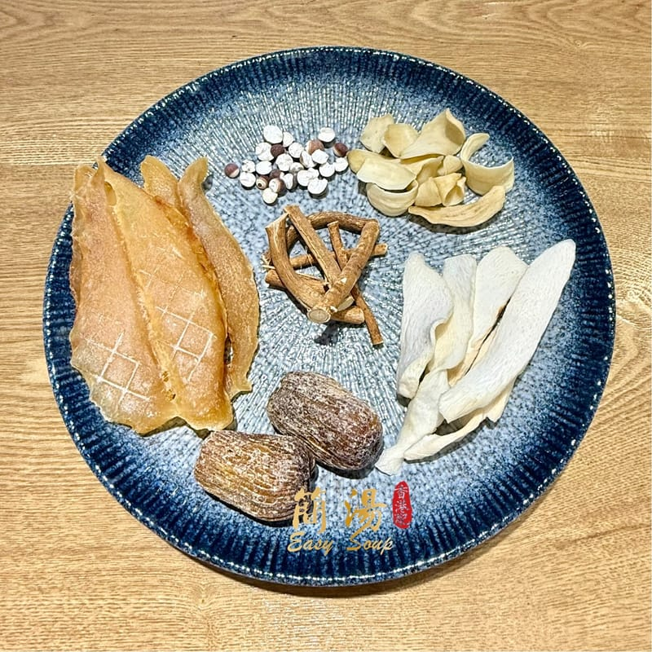  Five Finger Fig soup  五指毛桃健脾汤 | Chinese yam, Solomon’s seal, fox nuts, honey dates and tangerine peel appear in the illustrated record. We could not verify the full Five Finger Fig recipe. | Spleen and digestive support in traditional terms.
Table A3 Staff-described popular product categories

Product or category | Nature & Flavour | Meridian | Function | Application
Ginseng tonics  人参／西洋参 | Ginseng: sweet, slightly bitter; neutral. American ginseng: sweet, slightly bitter; cool. | Ginseng: Heart, Spleen, Lung. American ginseng: Heart, Lung, Kidney. | Staff linked use to fatigue, Qi support and immunity. | Staff described use for fatigue and general nourishment.
罗汉果  Monk-fruit products | Reference fruit: sweet and cool. | Reference fruit: Lung and Large Intestine. | Staff associated it with throat comfort and cooling. | Staff described fruit and drink forms. We did not record the recipes.
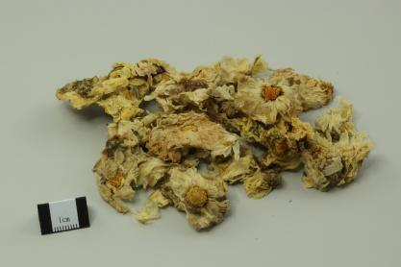  花茶／凉茶  Flower and herbal teas | Reference Ju Hua: sweet, bitter; slightly cold. | Reference Ju Hua: Lung, Liver. | Staff described everyday wellness uses. | Staff linked simple brewing to younger buyers.
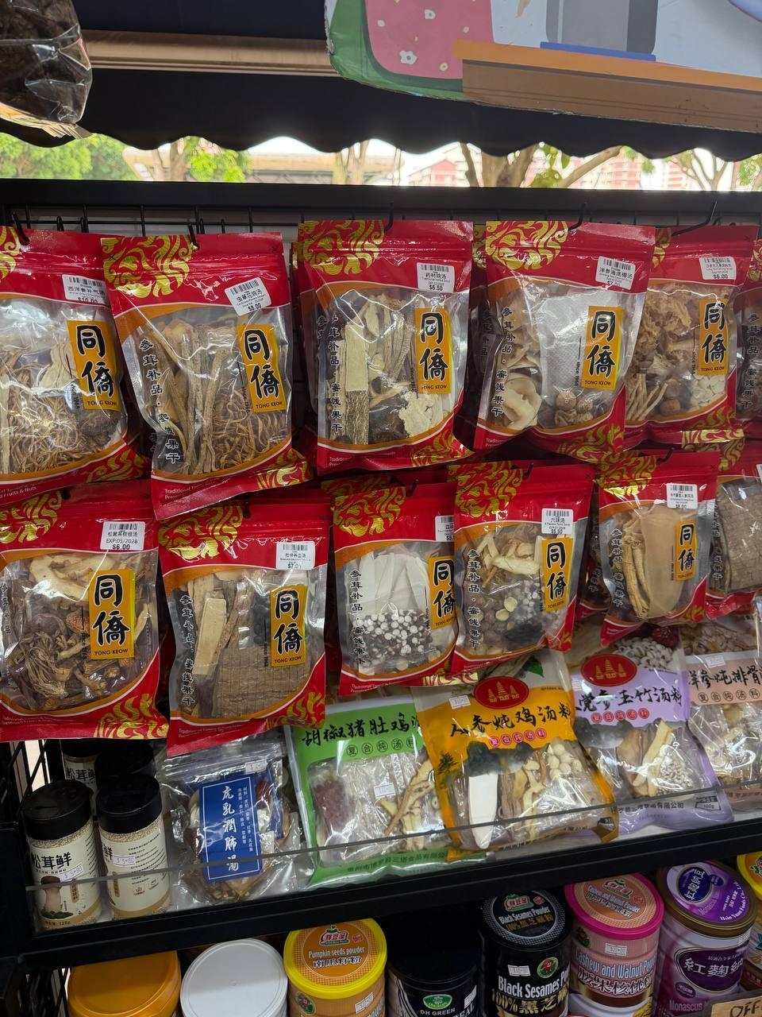  药材汤包  Soup packs | Examples: Huai Shan sweet, neutral; Yu Zhu sweet, slightly cold. | Huai Shan: Spleen, Lung, Kidney. Yu Zhu: Lung, Stomach. | Presentation: light nourishment. | Preselected dried packs still require cooking.
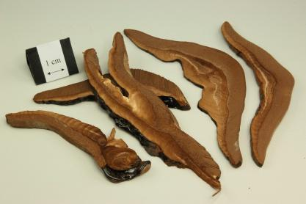  灵芝保健品  Lingzhi supplements | Reference Lingzhi: sweet; neutral. | Reference Lingzhi: Liver, Heart, Lung, Kidney. | Staff associated supplements with immunity support. | Staff described use for general wellness and immunity support.
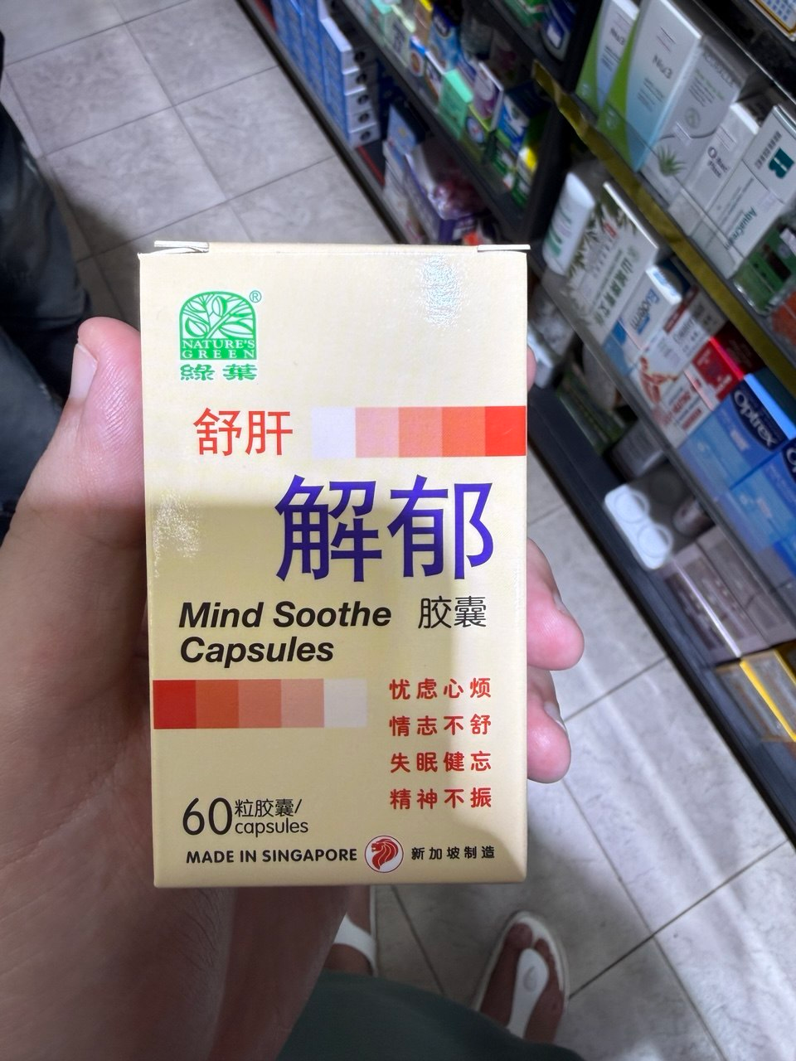  养肝／疏肝解郁  Nature’s Green 绿叶  Mind Soothe Capsules | Reference ingredients: Chai Hu—bitter, slightly cold; Suan Zao Ren—sweet, sour, neutral. | Chai Hu: Liver, Gallbladder. Suan Zao Ren: Liver, Gallbladder, Heart. | Staff described Liver nourishment and soothing constraint. The box uses “Mind Soothe” language. | Staff linked this category to late nights and stress.
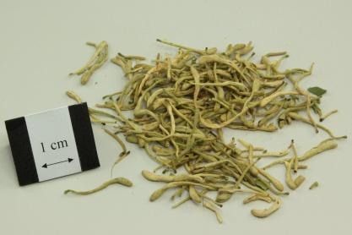  银翘类  Yin Qiao-type remedies | Reference honeysuckle: sweet; cold. | Reference honeysuckle: Lung, Heart, Stomach. | Staff associated this category with cold symptoms. | Staff described use for cold symptoms.
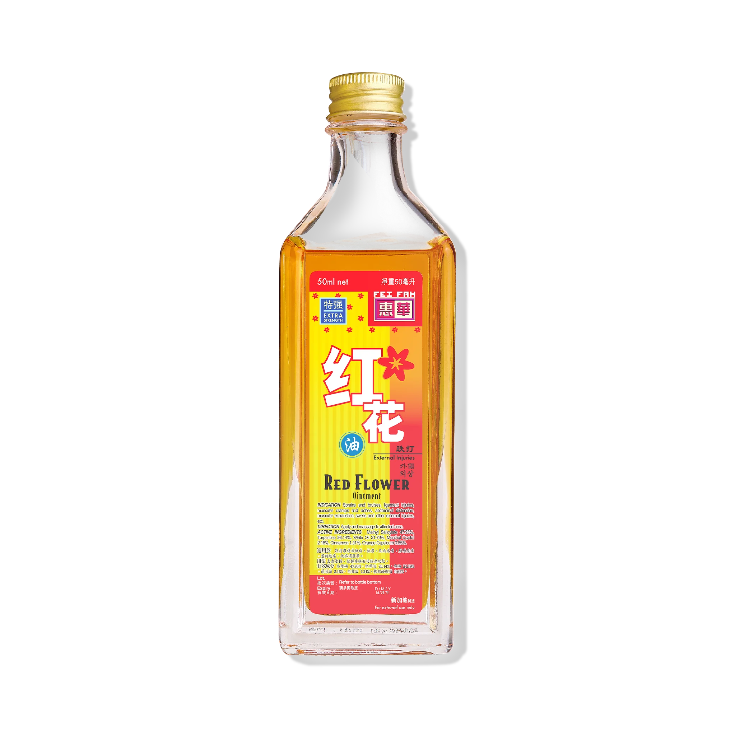  红花油／红油精  Medicated oils | The Fei Fah example is described as a warming topical liniment. Oral flavour classification does not apply. | This topical product is applied locally. A meridian affinity is not specified in the product description used here | Staff associated oils with aches and injuries. | Staff described external use, including by older customers.

Table A4 Staff-described lower-demand examples

Product or category | Application
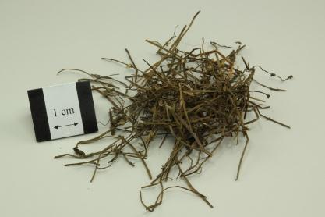  半枝莲 Ban Zhi Lian  Barbated skullcup herb | References describe Ban Zhi Lian as clearing heat/toxins, resolving stasis and promoting urination. They list sores, throat swelling and oedema. Staff linked lower demand to unfamiliarity and the need for combinations.
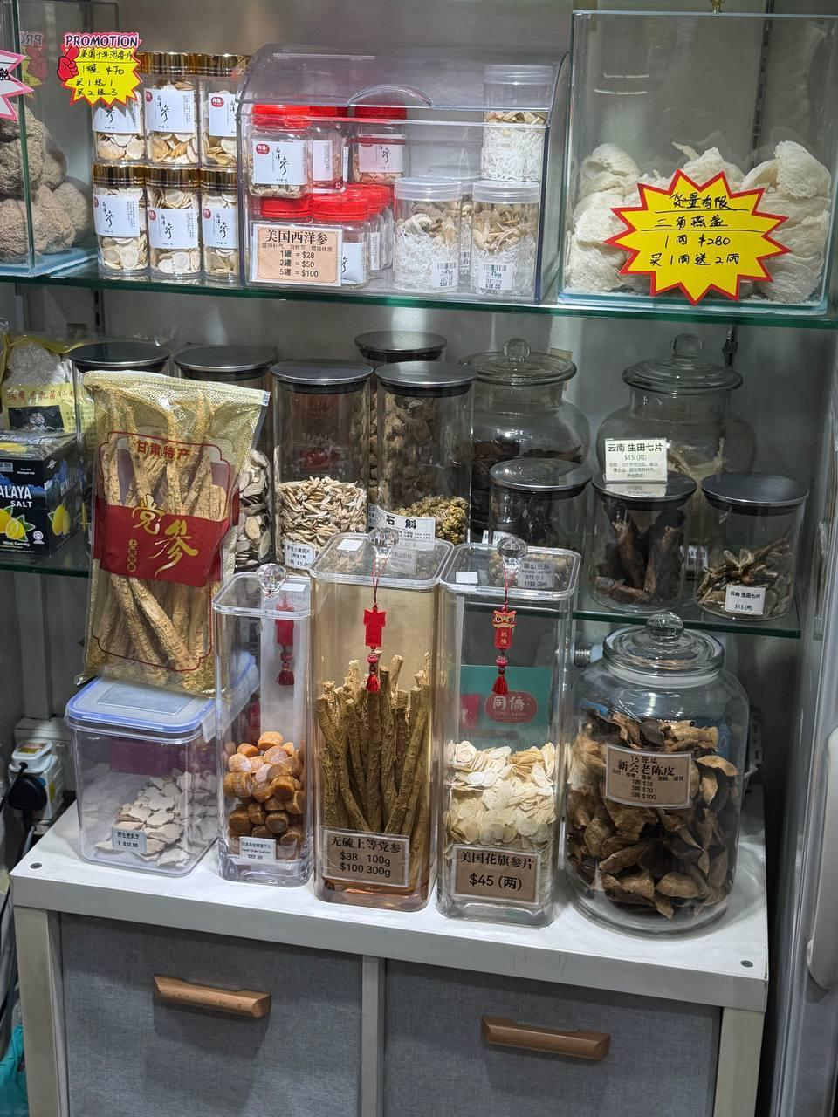  Specialist herbs | Staff said these herbs needed combinations and guidance. They named no specific formula. The reference discusses selecting and decocting combined herbs.
大补方  Strong tonic formulas | Staff said strong tonics for intensive replenishment had lower appeal than qing bu. They linked this preference to climate, but did not establish universal unsuitability. We recorded no formula. Constitution and condition guide selection.
Table A5 Five examples of Singapore production or local linkage

Example | Ingredient origin and cultivation in Singapore | Manufacture in Singapore | Processing, packaging or brand link
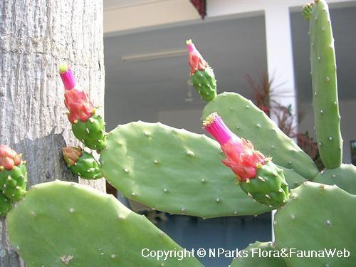  Cactus 仙人掌 | Staff named cactus as a possible cultivation example. Reference Opuntia cochenillifera is native to Mexico/Central America. The outlet species and stock origin remain unverified. | We did not verify a finished cactus product. | The reference plant has edible stems and supports stem-pad propagation. We identified no outlet producer, processor or packer.
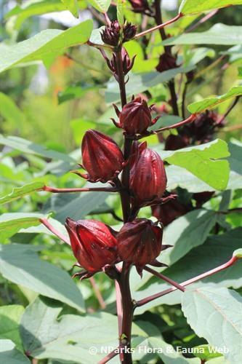  Roselle 洛神花 | Staff named roselle as a possible cultivation example. Roselle is native to parts of Africa. Outlet stock origins remain unverified. | Local cultivation is documented. Finished-product manufacture remains unverified. | Calyces are used in drinks. Staff named no outlet brand or processor.
Mind Soothe Capsules  舒肝解郁胶囊 | The manufacturer lists 16 ingredients, including bupleurum root, lily bulb and jujube. It does not disclose source countries or Singapore cultivation. | HSA names Tong Jum Chew as the manufacturer and Singapore as the manufacturing country. | The photograph shows a finished CPM under the Nature’s Green brand.
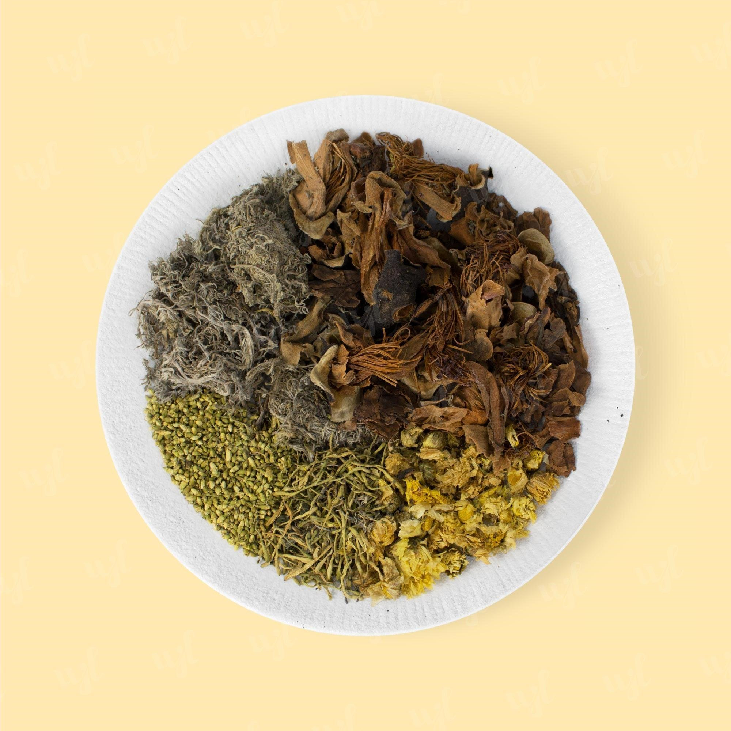  Five Flower Tea — external example  五花茶 | The reference blend contains frangipani, capillary wormwood, kapok, sophora, chrysanthemum and honeysuckle. The source does not disclose growing countries. | The label states “Product of Singapore” and “Packed in Singapore” separately. Cultivation remains unverified. | Wing Joo Loong’s Lung Soothing Summer Tea was previously called Five Flower Tea. Packing and branding are documented. Tong Keow stock remains unverified.
Monk fruit tea 罗汉果茶 — external example | The reference plant is native to southern China/northern Thailand. Beverage ingredient origins remain unverified. | The HFTea producer describes beverage manufacture in Singapore. | Heng Foh Tong owns the HFTea brand. This external manufacturing/branding example does not identify Tong Keow’s tea supplier.
Table A6 Staff-described product uses without confirmed clinical prescriptions

Complaint or wellness concern | Associated retail product | Reference ingredients and traditional-use context
Colds | 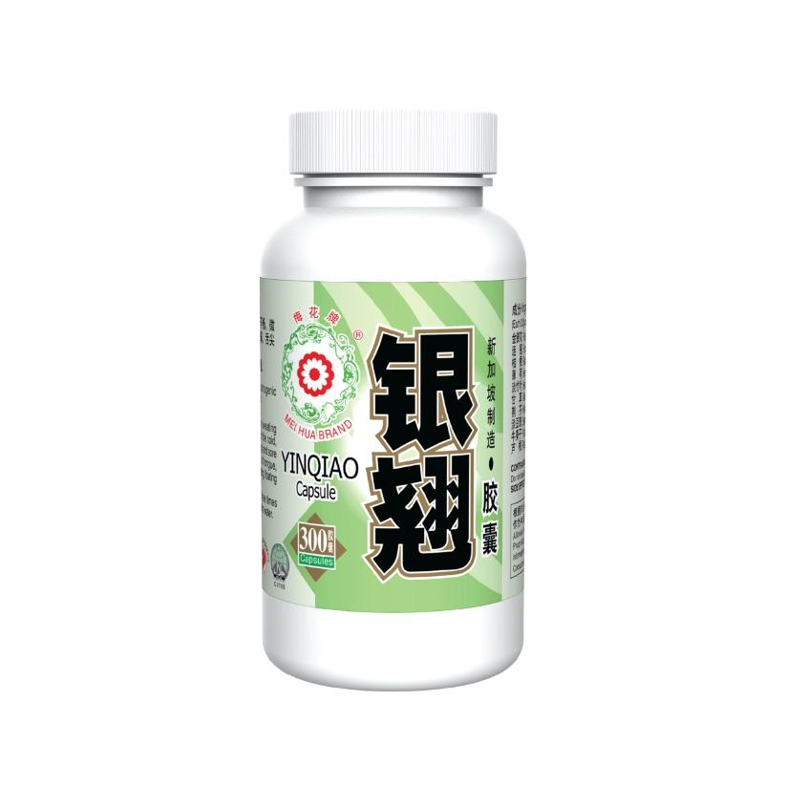  Yin Qiao type remedies | The external Mei Hua Yin Qiao example contains honeysuckle, forsythia, platycodon, mint, lophatherum, licorice, schizonepeta, prepared soybean, burdock fruit and reed rhizome. The manufacturer lists fever, sore throat, thirst, and tongue and pulse features as reference context.
Diarrhoea | 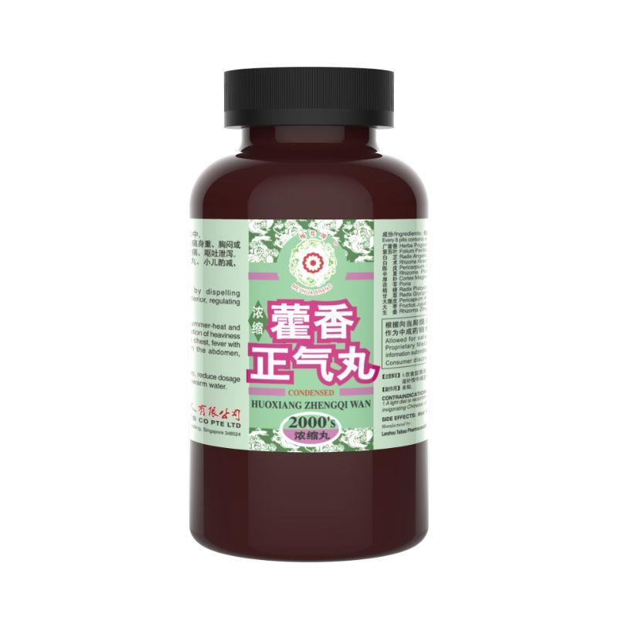  Huoxiang Zhengqi type remedies | The external Mei Hua Huoxiang Zhengqi example contains patchouli, perilla, angelica dahurica, atractylodes, tangerine peel, pinellia, magnolia bark, poria, platycodon, licorice, areca peel, jujube and ginger. The manufacturer lists dampness with vomiting, diarrhoea, fullness and heaviness as reference context.
Fatigue or Qi deficiency language | 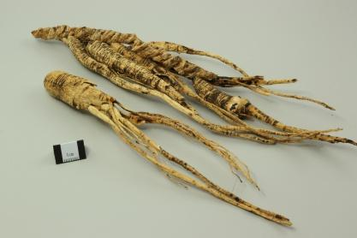  Ginseng or Dang Shen | Ginseng and Dang Shen are separate Qi-tonifying materials. Ginseng supports original Qi, and Dang Shen supports Spleen–Lung Qi. The references list poor appetite and breathlessness. The Dang Shen profile also lists loose stools.
Perceived lower immunity | 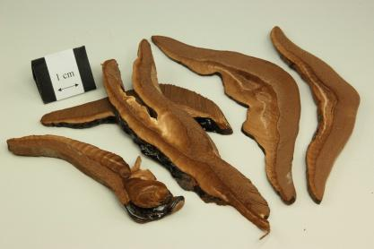  Lingzhi or supplements | The reference identifies Lingzhi as the fruiting body of Ganoderma lucidum/G. sinense. It describes Qi-tonifying and calming uses for insomnia, palpitations and breathlessness. Staff’s “immunity” language does not identify a clinical pattern.
Late nights, stress and long work hours | Liver care or mood support products | The reference Mind Soothe product has 16 ingredients, including bupleurum, acorus, lily, sour jujube seed, curcuma, polygala, licorice and jujube. The manufacturer describes Liver constraint, restlessness and sleep/mood concerns. Staff’s lifestyle account is not a diagnosis.
Aches or injuries | 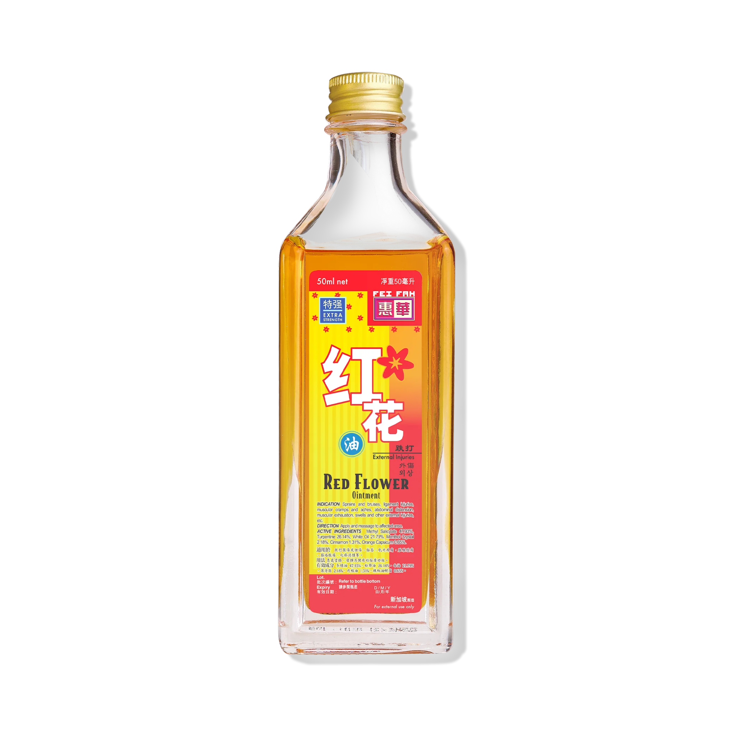  Medicated oils | The external Fei Fah ointment contains methyl salicylate, turpentine, white oil and menthol among its listed ingredients. The manufacturer describes uses for sprains, bruises and muscular aches. Other oils differ.

